Amazon Prime Video Content
Analytics Dashboard

Project Title:
Amazon Prime Content Analytics Dashboard – Content Library, Genre Performance, Audience Ratings & Cast Insights.

Dataset Details:
- Dataset Name: Amazon Prime Video Content Analytics Dataset

- Source: Amazon Prime Movies & TV Shows Dataset

- Platform: Amazon Prime Video

- Description: The Amazon Prime Video dataset contains information about movies and TV shows available on the streaming platform. Each record represents a unique title and includes attributes such as title, genre, release year, IMDb/TMDB ratings, runtime, popularity, certifications, cast information, and production details. The dataset is used to analyse content trends, audience preferences, genre distribution, ratings performance, and entertainment insights.

Key Attributes:
1. id:
Unique identifier for each movie or TV show.
2. title:
Name of the movie or TV show.
3. type:
Specifies whether the content is a Movie or TV Show.
4. description:
Brief summary or storyline of the content.
5. release_year:
Year in which the content was released.
6. age_certification:
Audience suitability rating (e.g., PG, R, TV-MA).
7. runtime:
Duration of the movie/show in minutes.
8. genres:
Categories of content such as Drama, Comedy, Action, Thriller, etc.
9. production_countries:
Country or countries where the content was produced.
10. seasons:
Number of seasons available for TV shows.
11. imdb_score:
IMDb rating score of the content.
12. imdb_votes:
Total number of votes received on IMDb.
13. tmdb_popularity:
Popularity score obtained from TMDB.
14. tmdb_score:
TMDB rating score of the content.
15. person_id:
Unique identifier of cast members or contributors.
16. name:
Name of the actor, actress, or contributor.
17. character:
Character played in the movie or TV show.
18. role:
Role category such as actor, director, or contributor.

Dashboard Objective:
The primary objective of this dashboard is to:
- Analyse Amazon Prime's content library.
- Understand content growth over time.
- Identify top-performing genres.
- Evaluate audience ratings and popularity.
- Examine content distribution across countries.
- Analyse cast and director contributions.
- Support content acquisition and production decisions using data-driven insights.

Screenshots of Dashboard and Insights:

Dashboard 1: Overview Analysis - Provides a high-level summary of Amazon Prime's content library.

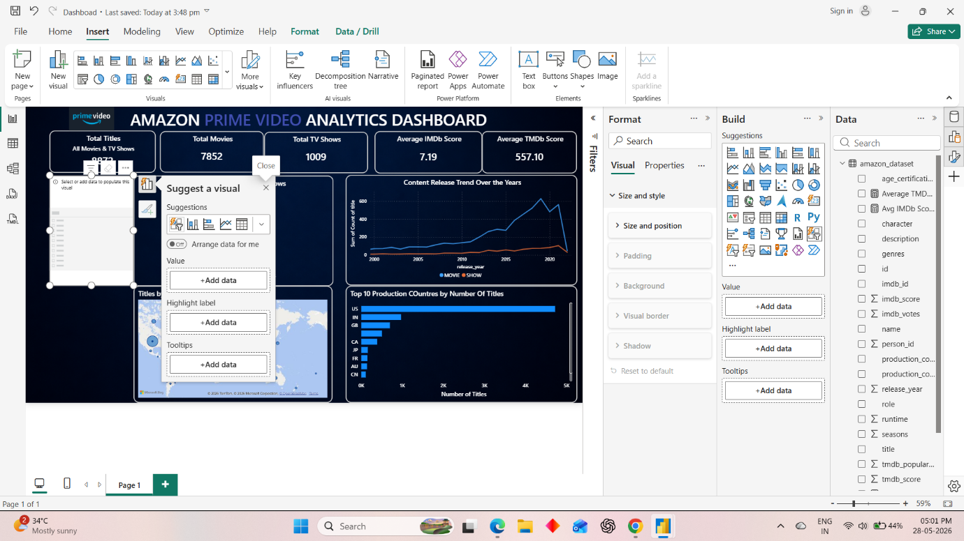

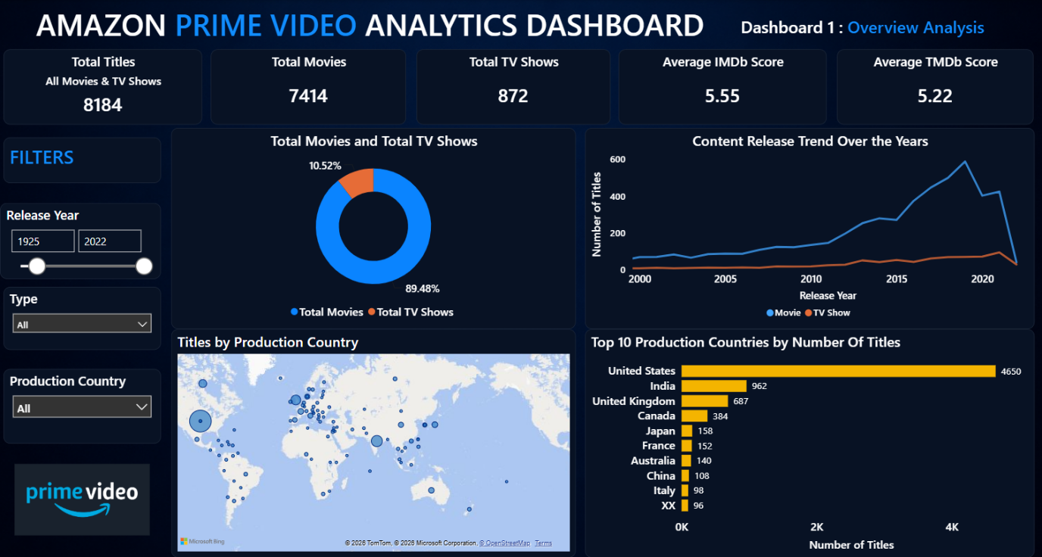

KPIs:
  - Total Titles: Shows total number of titles available on the platform. Measures catalogue size. Tracks overall content growth.
  - Total Movies: Shows total movie count. Helps understand movie dominance. Supports movie acquisition planning.
  - Total TV Shows: Shows total TV show count. Measures series content strength. Helps balance movie vs TV content strategy.
  - Average IMDb Score: Displays average audience rating. Measures overall content quality. Helps benchmark against competitors.
  - Average TMDb Score: Displays average TMDb rating. Provides another quality indicator. Validates audience satisfaction.

Donut Chart: Total Movies & Total TV Shows
It Shows Percentage share of Movies and TV Shows. Movies occupy the majority of Amazon Prime's catalogue. TV Shows represent a smaller but important segment. Donut chart helps to determine future investment allocation and supports content diversification strategy.

Line Chart: Content Release Trend Over Years
It shows Number of titles released over time and Identifies periods of rapid content expansion. Line Chart shows trends in content production and helps forecast future content demand with assists strategic planning.

Map: Global Content Distribution
It shows Content count by production country by highlighting regions producing the most content. It helps to Identify strong and weak markets and supports international expansion decisions.

Bar Chart: Top 10 Production Countries by Number of Titles
It shows Countries with the highest number of titles and reveals major content-producing countries. It helps to prioritize regional partnerships and supports in making localization strategies.

Dashboard 2: Genre & Content Analysis – Analyse Genre performance and Popularity.

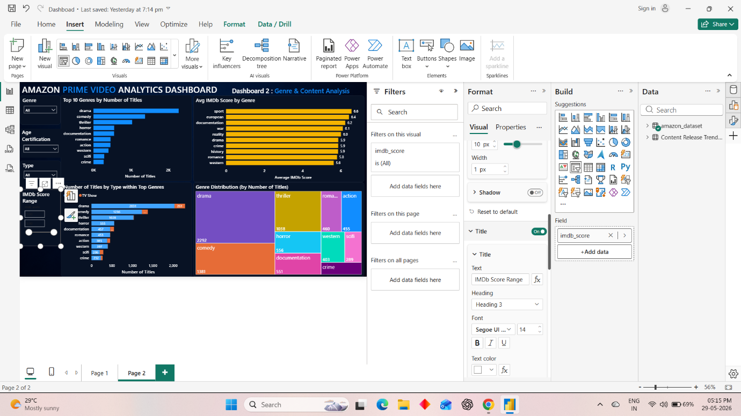

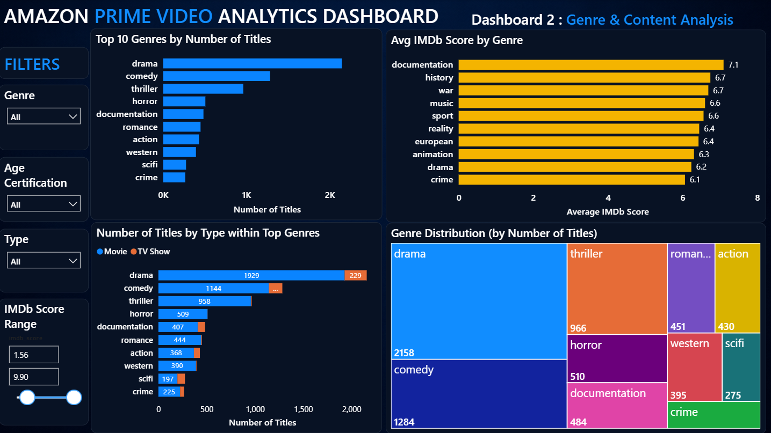

Bar Chart: Top 10 Genres by Number of Titles
It shows Genres with the highest content volume. It helps to Identify dominant genres in the catalogue which guides future content acquisition. Further helping in maintaining audience preferences.
Bar Chart: Average IMDb Score by Genre
It shows Average audience rating for each genre and reveals highest-quality genres. Helping to invest in genres delivering better audience satisfaction.

Tree map: Genre Distribution (by Number of Titles)
It shows Relative contribution of each genre and quickly identifies major and niche genres. Helping in maintaining genre diversity and supporting portfolio balancing.

Stacked Bar Chart: Number of Titles by Type within Top Genres
It shows Movies and TV Shows count within each genre. Thus, revealing whether genres perform better as movies or show further guiding format-specific content creation.

Dashboard 3: Ratings and Popularity Analysis - Evaluates audience engagement and content quality.

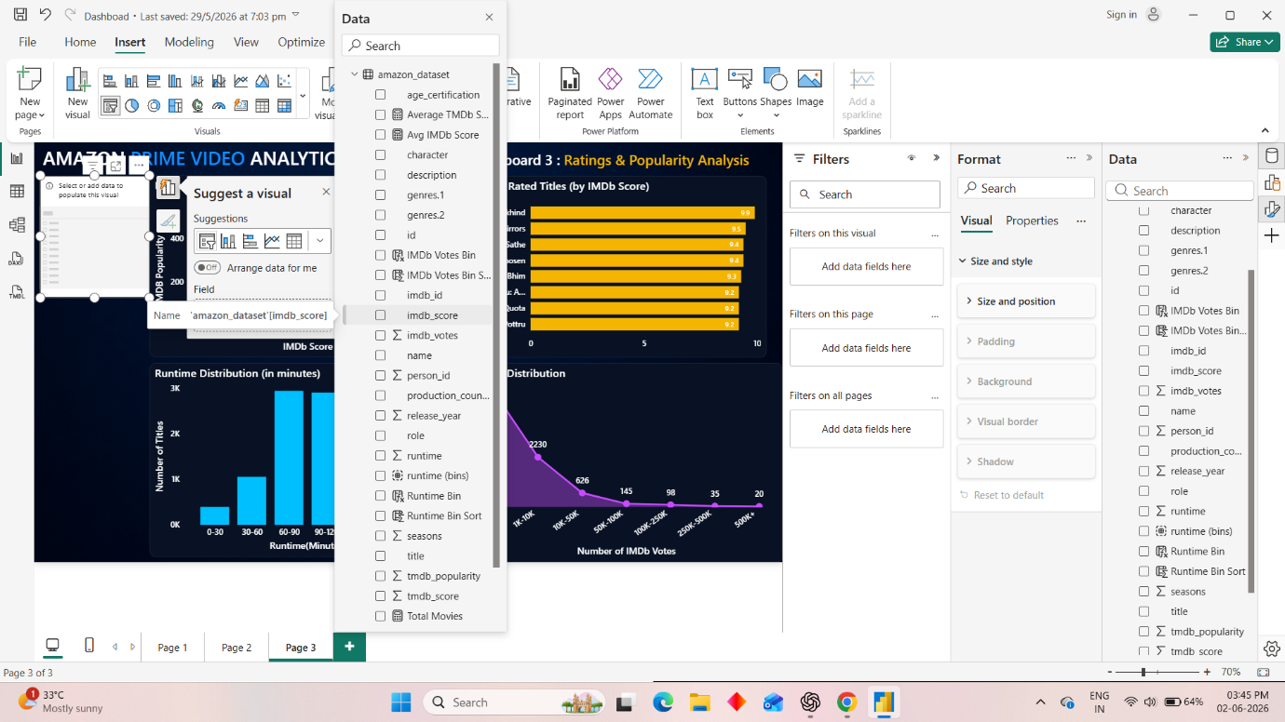

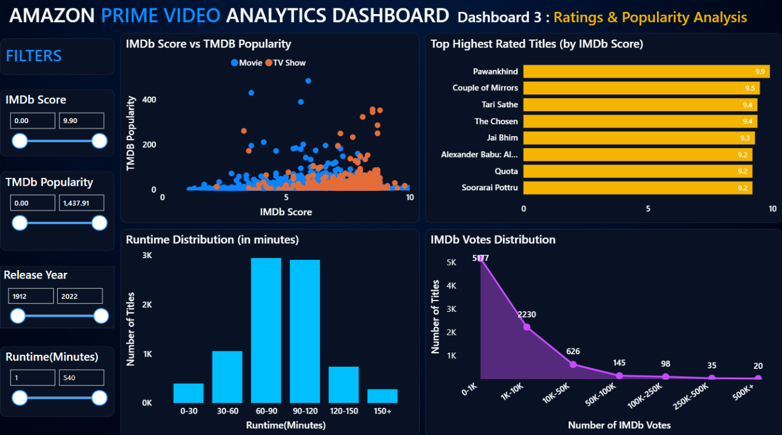

Scatter Plot: IMDb Score vs TMDb Popularity
It shows relationship between ratings and popularity. High rated titles may not always be highly popular. Some popular titles may have average ratings. It helps to identify hidden gems and supports recommendation systems.

Bar Chart: Highest Rated Titles (by IMDb Score)
It shows Top-rated content based on IMDb score and Identify premium-quality titles.
It is useful for promotions and featured recommendations.

Column Chart: Runtime Distribution (in minutes)
It shows Number of titles across runtime ranges, revealing preferred content durations
which helps to optimize future content production lengths.

Area Chart: IMDb Votes Distribution
It shows Distribution of titles by vote count. Depicts audience engagement levels and
Helps to identify highly discussed and influential titles.

Dashboard 4: Cast & Production Analysis - Analyses contributions of actors and directors.

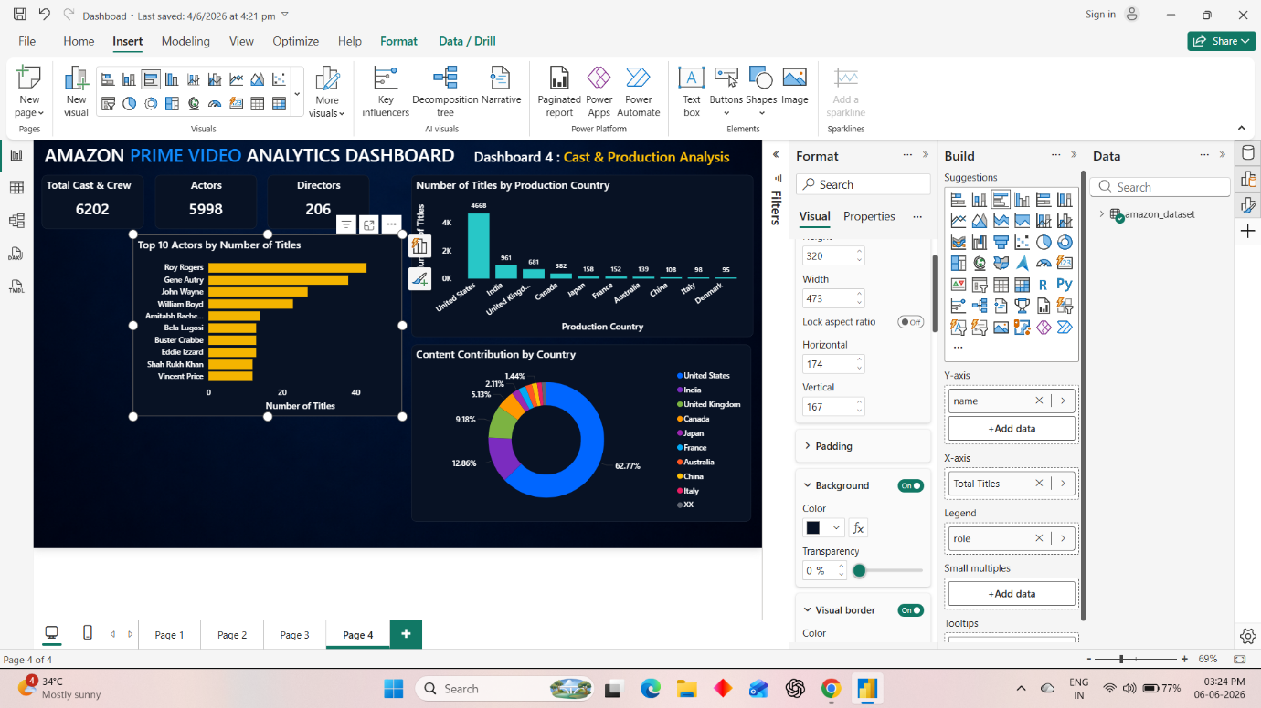

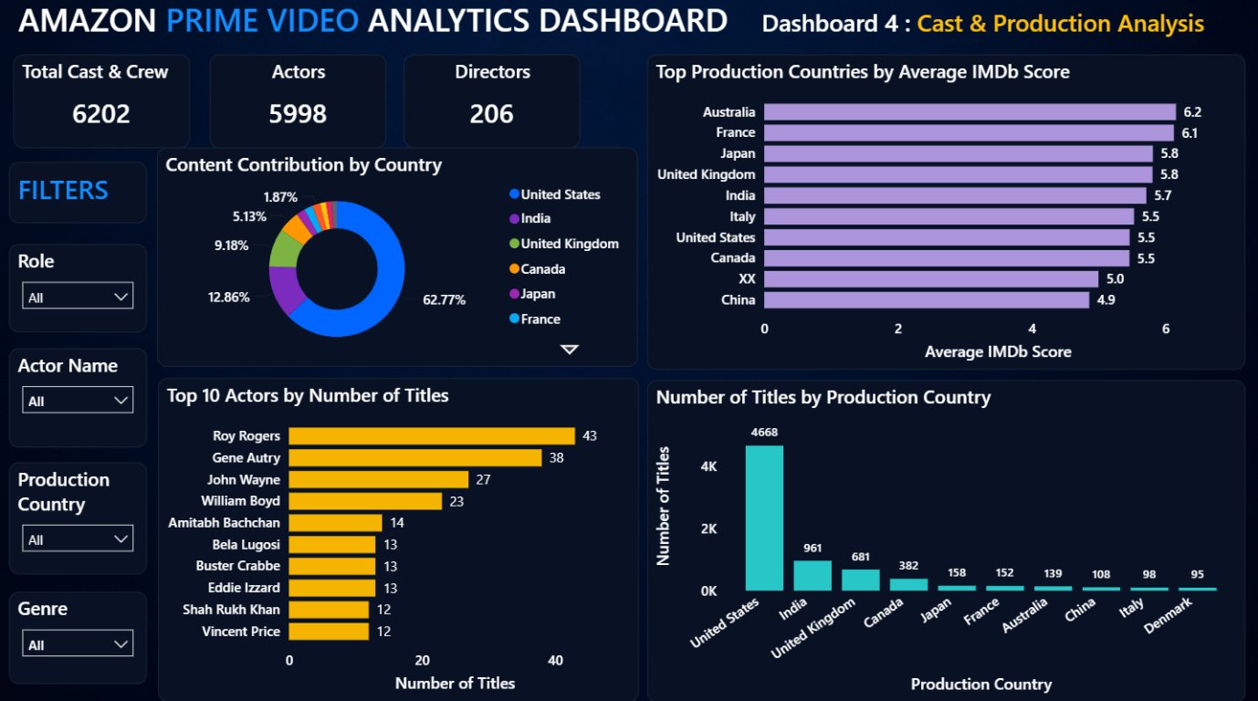

KPIs:
- Total Cast & Crew: Count total number of cast and crew members and indicate overall talent diversity.
- Total Actors: It Shows number of actors represented further measuring acting talent pool size.
- Total Directors: It Shows number of directors represented further measuring creative leadership diversity.

Bar Chart: Top 10 Actors by Number of Titles
It shows most frequently appearing actors. Thus, helping recognize successful talent partnerships.

Column Chart: Number of Titles by Production Country
It Shows number of titles produced in each country. Thus, revealing major content hubs and supporting international content strategy.

Donut Chart: Content Contribution by Country
It shows Percentage contribution of each country and visualizes geographical content concentration. Thus, helping to assess global market dependence.

Bar Chart: Top Production Country by Average IMDb Score
It shows Average content quality across countries. Further identifying countries producing highly rated content. It supports investment in high-performing regions.

Business Impact Summary:

This dashboard helps Amazon Prime:
- Optimize content acquisition strategy.
- Identify high-performing genres.
- Improve recommendation systems.
- Expand into promising international markets.
- Discover valuable talent partnerships.
- Balance movies and TV shows effectively.
- Prioritize content with strong audience ratings.
- Make data-driven content investment decisions.

